Test Case: tc005_SPX_Dev5_Crear_Requisicion_Spot_Con_FAD_Tipo_Cobro_Project
Step 1 - Enter username and password and click to button Enter: Credentials Entered
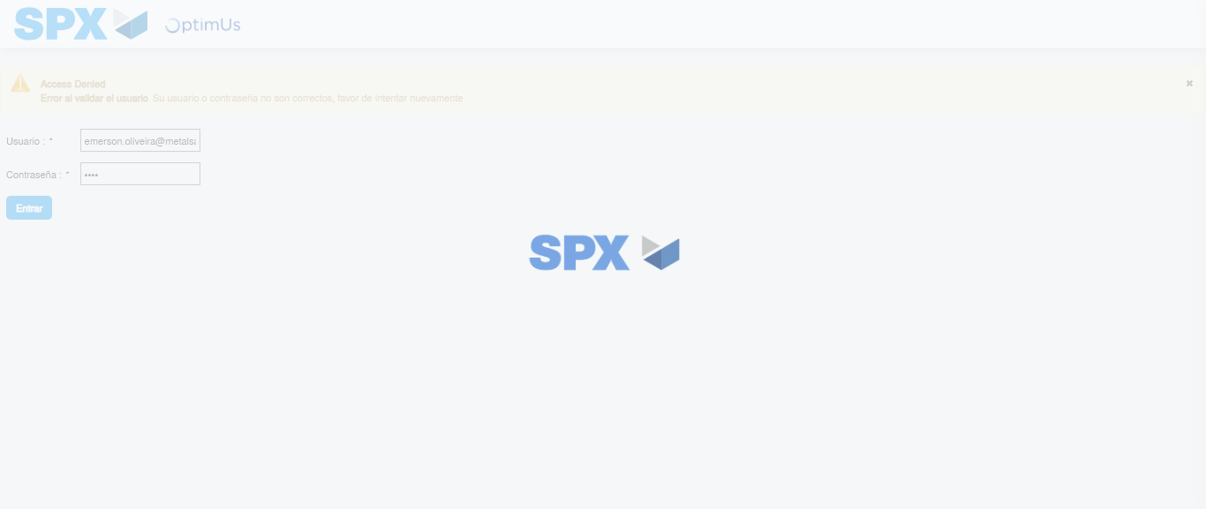Image file-name: QC_Testing-tc005_SPX_Dev5_Crear_Requisicion_Spot_Con_FAD_Tipo_Cobro_Project-1785975805282

Step 2 - Select to UEN and Access to Spot Buy Requisitions : UEN Correctly selected and Correct access
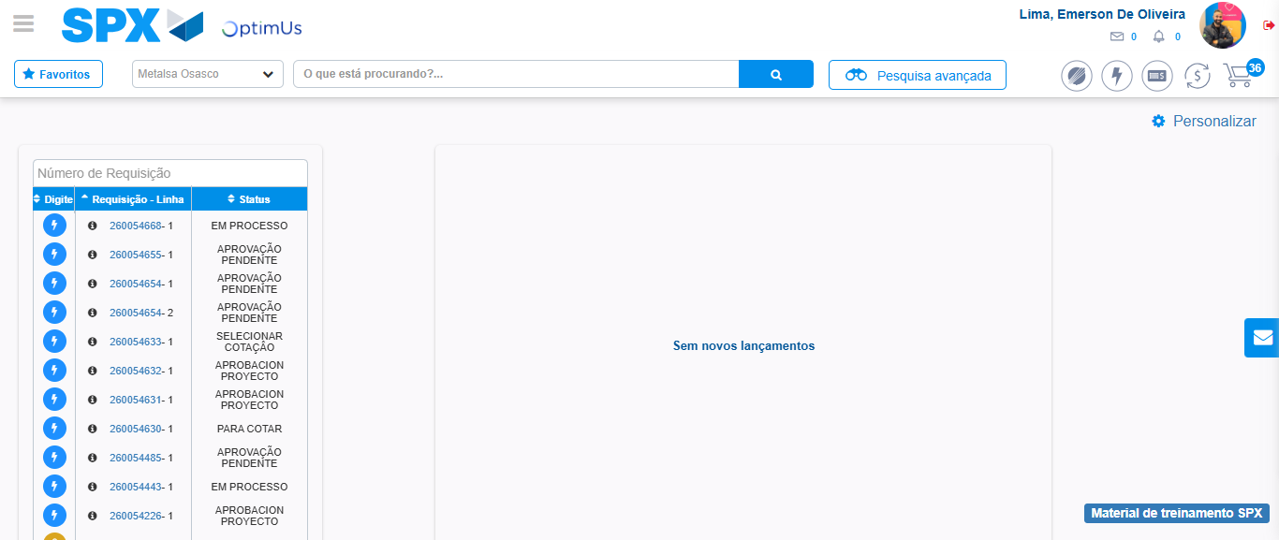Image file-name: QC_Testing-tc005_SPX_Dev5_Crear_Requisicion_Spot_Con_FAD_Tipo_Cobro_Project-1785975829912

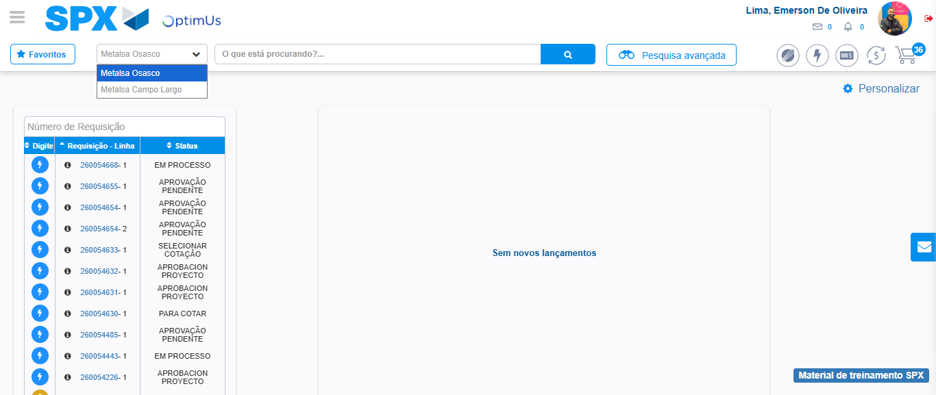Image file-name: QC_Testing-tc005_SPX_Dev5_Crear_Requisicion_Spot_Con_FAD_Tipo_Cobro_Project-1785975832574

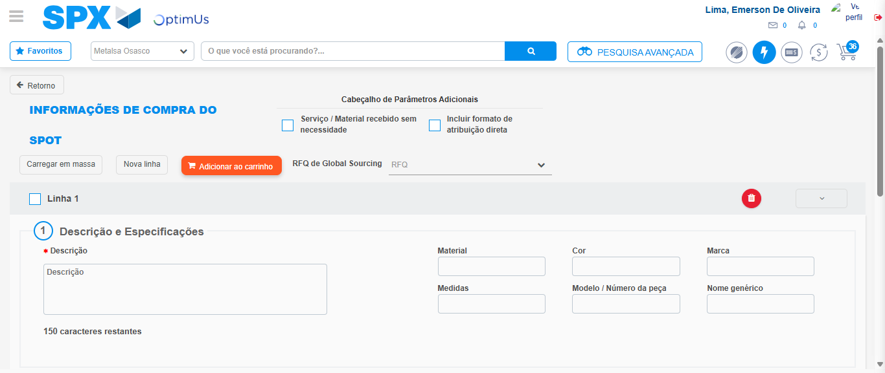Image file-name: QC_Testing-tc005_SPX_Dev5_Crear_Requisicion_Spot_Con_FAD_Tipo_Cobro_Project-1785975842932

Step 3 - Add FAD to Requisition: FAD Successfully Added
Image file-name: QC_Testing-tc005_SPX_Dev5_Crear_Requisicion_Spot_Con_FAD_Tipo_Cobro_Project-1785975843160

Image file-name: QC_Testing-tc005_SPX_Dev5_Crear_Requisicion_Spot_Con_FAD_Tipo_Cobro_Project-1785975843354

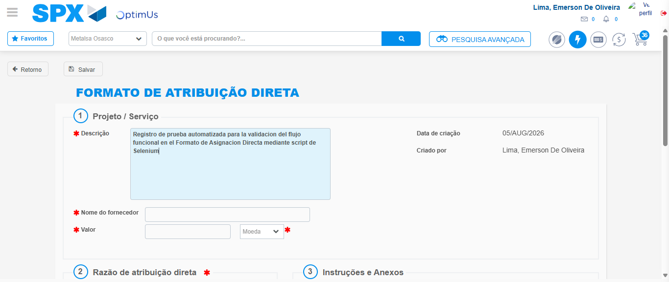Image file-name: QC_Testing-tc005_SPX_Dev5_Crear_Requisicion_Spot_Con_FAD_Tipo_Cobro_Project-1785975846332

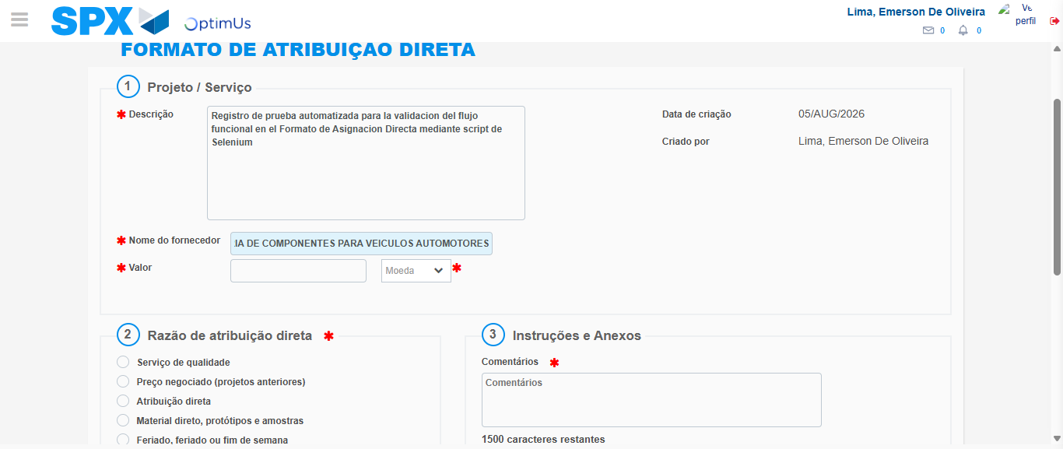Image file-name: QC_Testing-tc005_SPX_Dev5_Crear_Requisicion_Spot_Con_FAD_Tipo_Cobro_Project-1785975857096

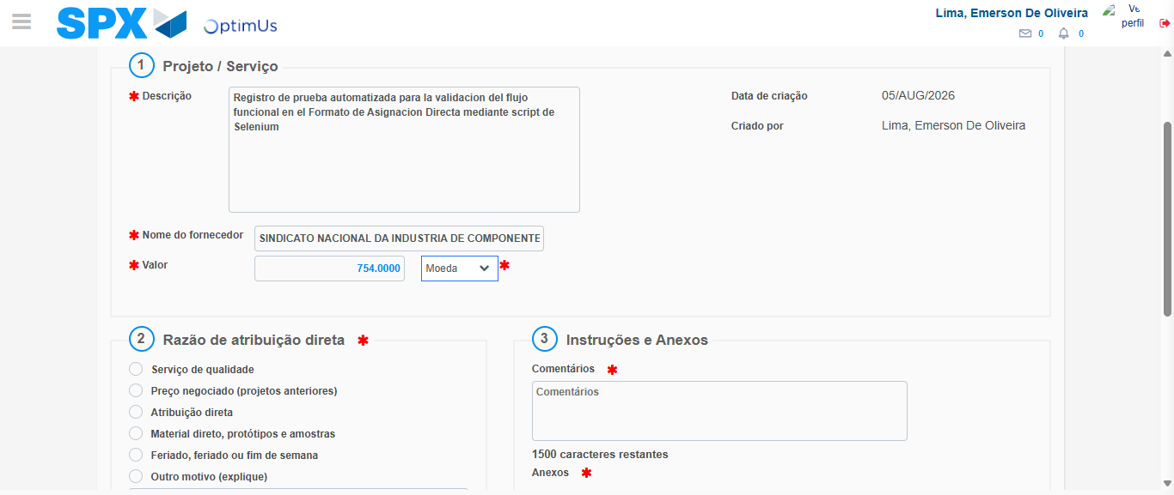Image file-name: QC_Testing-tc005_SPX_Dev5_Crear_Requisicion_Spot_Con_FAD_Tipo_Cobro_Project-1785975857716

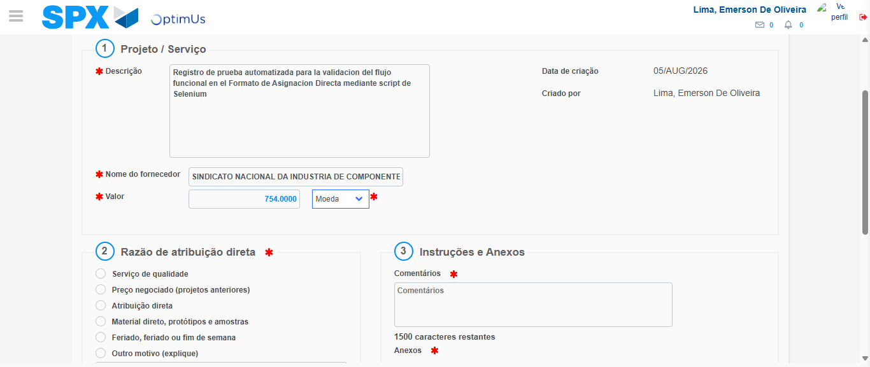Image file-name: QC_Testing-tc005_SPX_Dev5_Crear_Requisicion_Spot_Con_FAD_Tipo_Cobro_Project-1785975857991

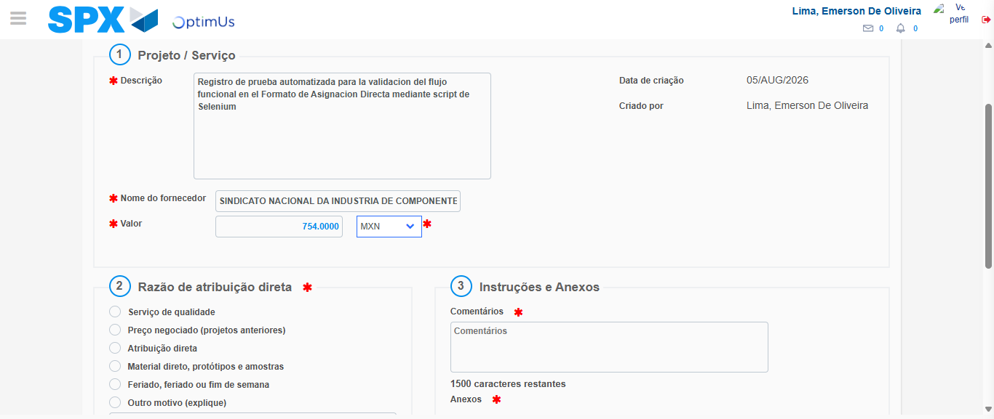Image file-name: QC_Testing-tc005_SPX_Dev5_Crear_Requisicion_Spot_Con_FAD_Tipo_Cobro_Project-1785975858413

Image file-name: QC_Testing-tc005_SPX_Dev5_Crear_Requisicion_Spot_Con_FAD_Tipo_Cobro_Project-1785975858617

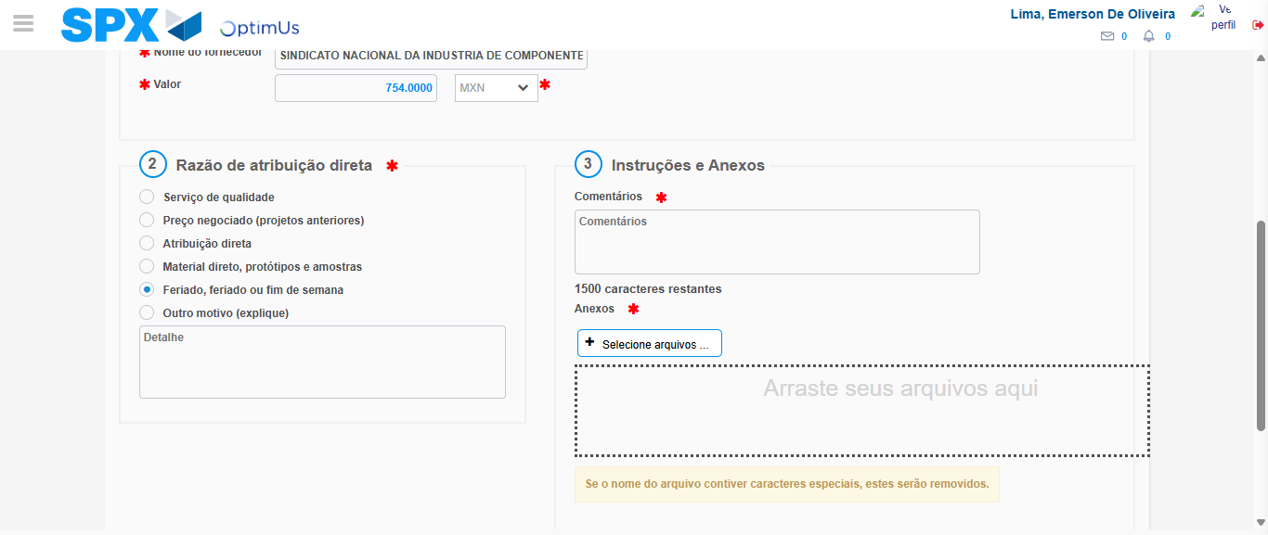Image file-name: QC_Testing-tc005_SPX_Dev5_Crear_Requisicion_Spot_Con_FAD_Tipo_Cobro_Project-1785975859539

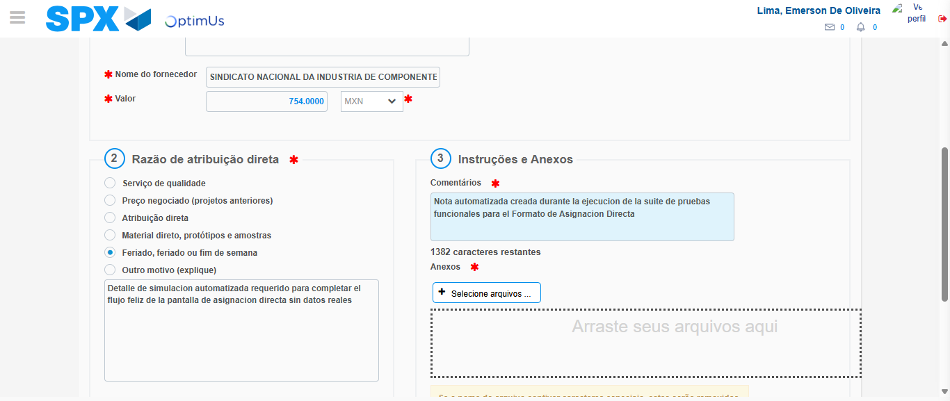Image file-name: QC_Testing-tc005_SPX_Dev5_Crear_Requisicion_Spot_Con_FAD_Tipo_Cobro_Project-1785975870632

Image file-name: QC_Testing-tc005_SPX_Dev5_Crear_Requisicion_Spot_Con_FAD_Tipo_Cobro_Project-1785975871399

Step 4 - Data Capture Spot Buy Requisition: Data captured correctly
Image file-name: QC_Testing-tc005_SPX_Dev5_Crear_Requisicion_Spot_Con_FAD_Tipo_Cobro_Project-1785975843160

Image file-name: QC_Testing-tc005_SPX_Dev5_Crear_Requisicion_Spot_Con_FAD_Tipo_Cobro_Project-1785975843354

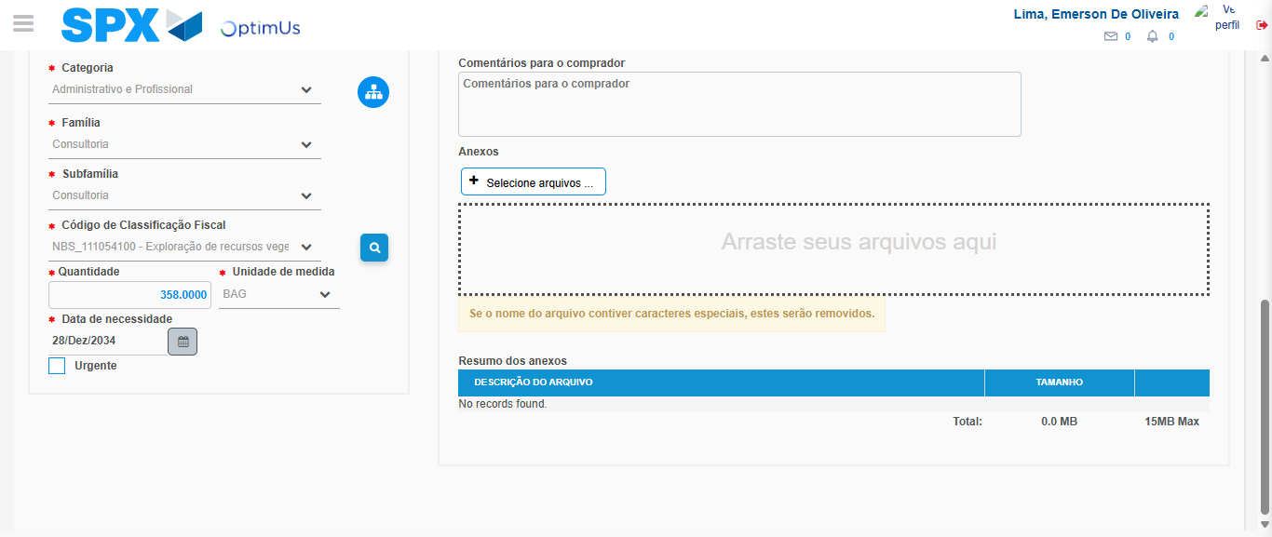Image file-name: QC_Testing-tc005_SPX_Dev5_Crear_Requisicion_Spot_Con_FAD_Tipo_Cobro_Project-1785975889550

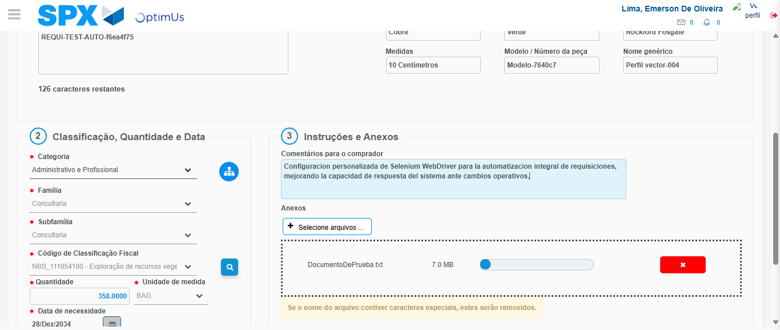Image file-name: QC_Testing-tc005_SPX_Dev5_Crear_Requisicion_Spot_Con_FAD_Tipo_Cobro_Project-1785975890300

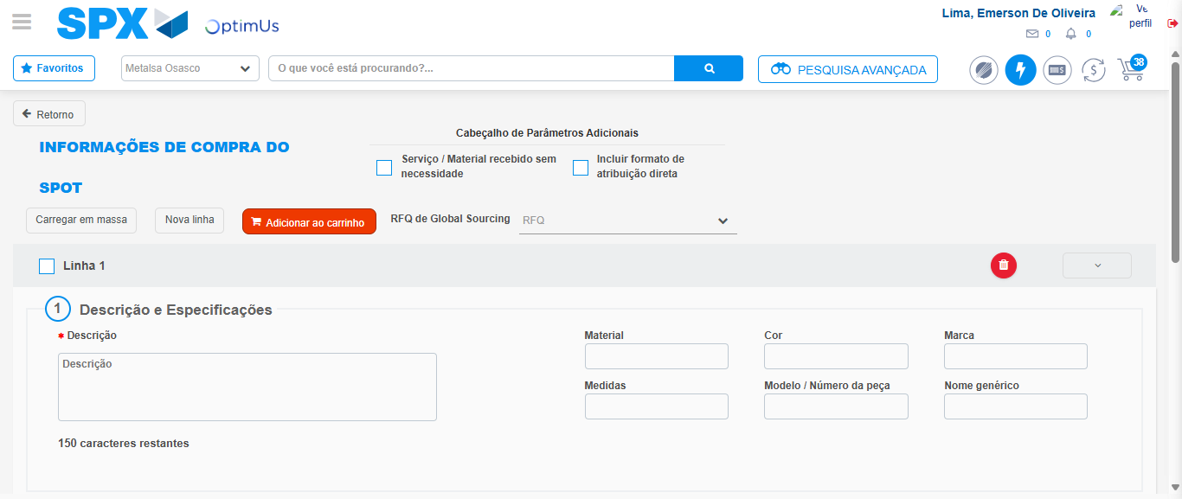Image file-name: QC_Testing-tc005_SPX_Dev5_Crear_Requisicion_Spot_Con_FAD_Tipo_Cobro_Project-1785975899218

Step 8 - Return to Main Page SPX : Return to Main Page SPX
Image file-name: QC_Testing-tc005_SPX_Dev5_Crear_Requisicion_Spot_Con_FAD_Tipo_Cobro_Project-1785975829912

Image file-name: QC_Testing-tc005_SPX_Dev5_Crear_Requisicion_Spot_Con_FAD_Tipo_Cobro_Project-1785975832574

Image file-name: QC_Testing-tc005_SPX_Dev5_Crear_Requisicion_Spot_Con_FAD_Tipo_Cobro_Project-1785975842932

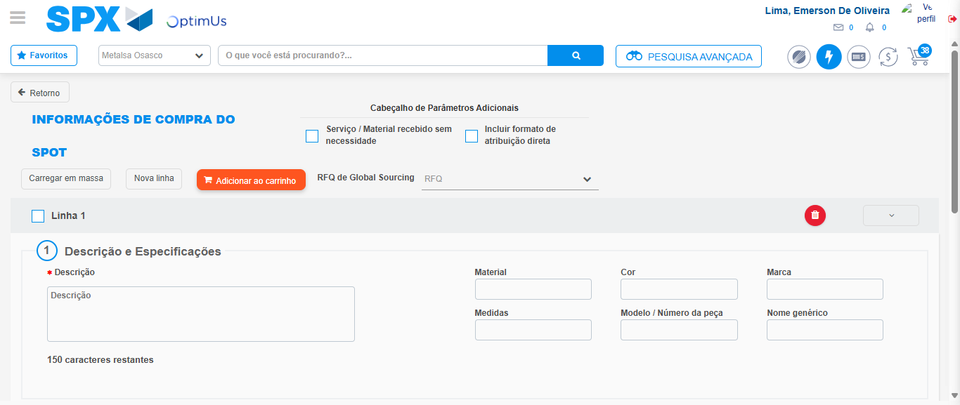Image file-name: QC_Testing-tc005_SPX_Dev5_Crear_Requisicion_Spot_Con_FAD_Tipo_Cobro_Project-1785975901594

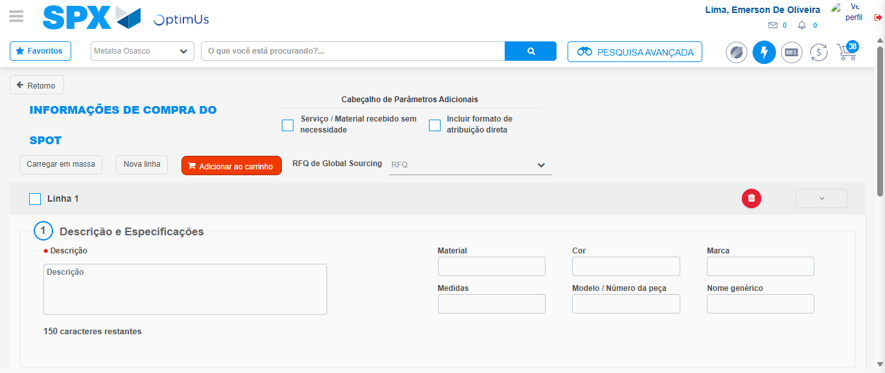Image file-name: QC_Testing-tc005_SPX_Dev5_Crear_Requisicion_Spot_Con_FAD_Tipo_Cobro_Project-1785975901885

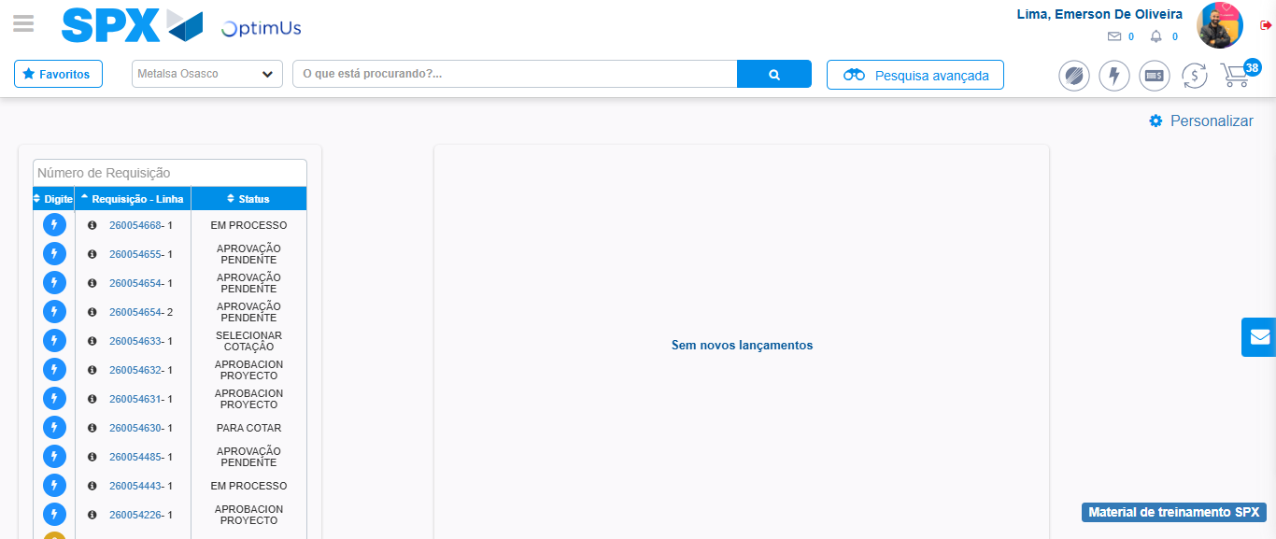Image file-name: QC_Testing-tc005_SPX_Dev5_Crear_Requisicion_Spot_Con_FAD_Tipo_Cobro_Project-1785975922957

Step 9 - Log Out : Log Out SPX
Image file-name: QC_Testing-tc005_SPX_Dev5_Crear_Requisicion_Spot_Con_FAD_Tipo_Cobro_Project-1785975923241

